Natural Language Processing Assignment 2

Intent
In this Assignment , I have implemented
- Smith-Waterman Algorithm
- Affine Gap Algorithm
- Spell Checker that uses an online dictionary and returns the best match

1.Smith-Waterman Algorithm
I implemented the smith-waterman Algorithm by modifying the stredit.stredit2 function
Output of this Algorithm
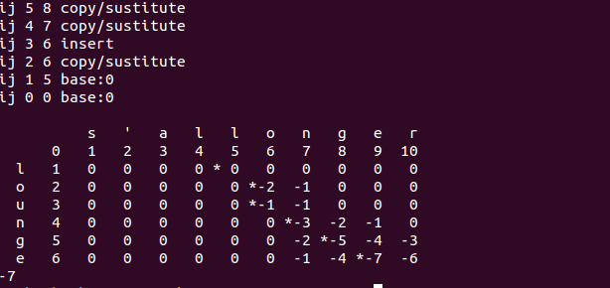
For this case the distances used were : insert/delete : 1 / copy cost : -2 / subst cost : 1 / base : 0
Hence the matched word is longer .

Analysis of this Algorithm
I tried different experiments with the distances for insert/delete/copy and substitute.
Case 1: For insert/delete : 100 copy : -2 substitute : 1
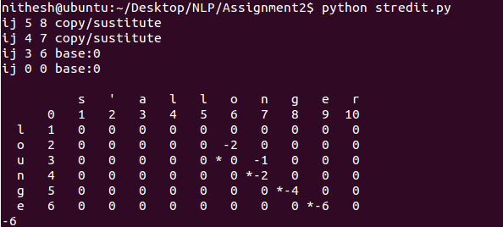
Case 2: For insert/delete : 1 copy : -2 substitute : 100
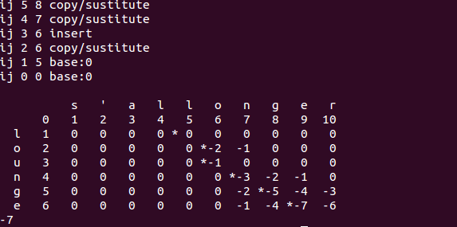
Case 3: For insert/delete : 1 copy : -10 substitute : 1
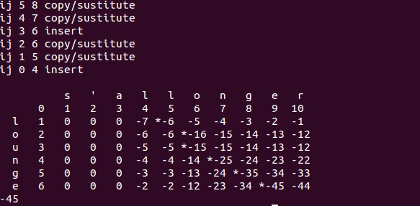
Result
For the case 1 , due to high insert and delete cost , the system preferred copy and substitute and hence the words matched were more or less of the same size
For the second case , since the substitution was more expensive , the system preferred copy or insert/delete and hence the output could delete/add more characters but did not substitute any characters
For the third case , the system would always prefer copy which could happen only if the same character occurs in both the strings . Hence the increase in this size did not have much effect . Independent of the magnitude , copy was always chosen

2.Affine Gap Algorithm
I implemented the Affine gap algorithm after referring to the material available at
http://pages.cs.wisc.edu/~bsettles/ibs08/lectures/02-alignment.pdf
In this algorithm , we compute the max function and positive distances for copy and negative distances for inserting gaps.
Output of this Algorithm

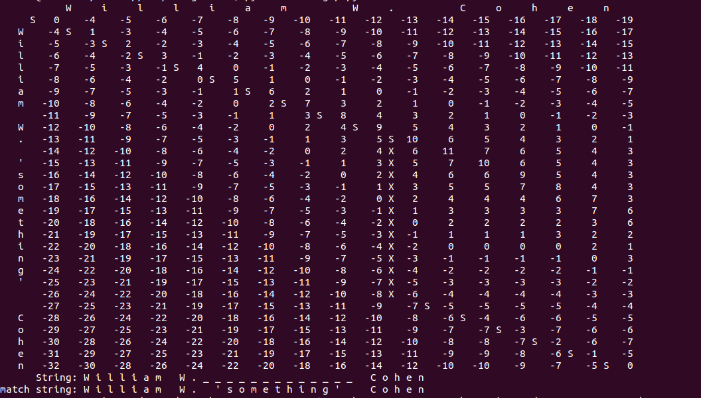
I have attached the snapshot of the output .
Here this table is a abstracted version of the original table .
A 3d table is produced by the algorithm and we choose just the most optimal path and print it
Here the trace is represented using
S – substitution
X – Insert a gap in the X string
Y – Insert a gap in the Y string

Analysis of this Algorithm
Case 1 : Copy cost 1(Only if the characters match ) / Insertion Cost -1(X/Y)
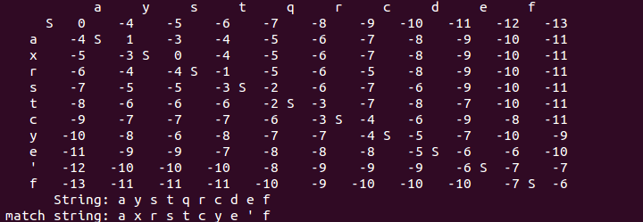
Case 2 : Copy cost 10(Only if the characters match) / Insertion Cost -1(X/Y)
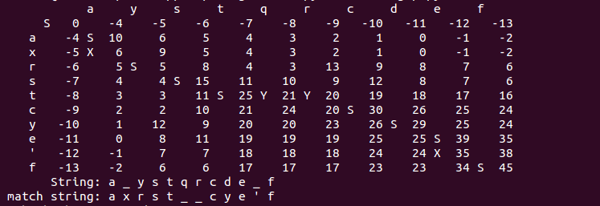
Case 3: Copy cost 1 ( only if characters match) / Insertion Cost -10(X/Y)
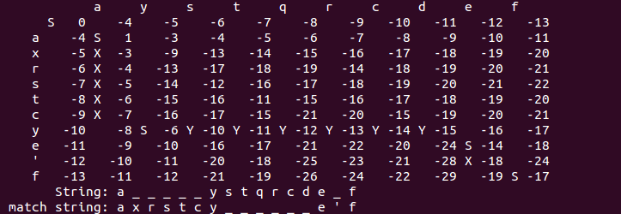

Result
In the first case both the penalty of other operations and the gain in copying the same characters are the same and hence the system decides to substitute ( one of the other operations) .
However in the second case when the gain in copying increases 10 times , the system tries to perform copying as many times as possible . Since the penalty of performing other operations isn't much , the system does perform other operations just to match the same characters in both the strings
In the third case , the system can perform copying only if both the strings have the same character . For the other cases it will have to perform other operations and there is nothing it can do about it . Hence it decides to perform insertions . Note that this is just optimal path , there are many and the code just prints out one of them

Spell Checker
I also implemented a spell checker by using a word dictionary from the Internet . I apply the smith-waterman algorithm to find the closest match and return that as output . The user has to call the python file with the word as the first argument
Sample Output of this Algorithm
python spellchecker.py wprd
ward
python spellchecker.py wordasard
wordage

